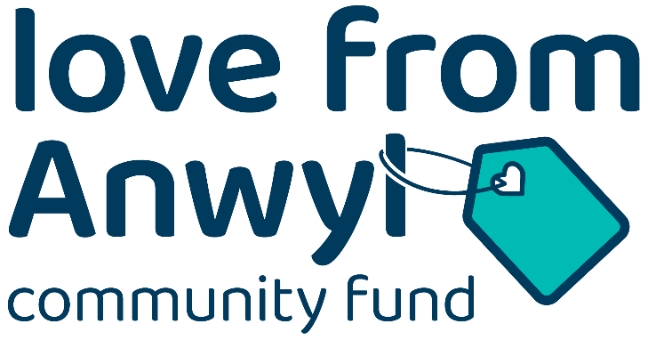

Chorlton Community Fund Application Form
Giving back to the people of Chorlton, Manchester with monetary donations, Love from Anwyl.
Grants of up to £1,500 for not-for-profit organisations to help support projects in the community

Organisation name and address (inc postcode):

Applicant name:

Contact email address:

Contact daytime tel no: (mobile & landline)

Amount of money requested

How will this be used to help the community?
Guidance on completing your application

Guidance on completing your application.
- Please email your completed application form to community@anwyl.co.uk. Remember to
- include ‘Chorlton Fund’ and your organisation name in the subject of your email.
- The total financial support available is £5,000, which will be released in phases.
- Please note that we aim to help a variety of groups and spread the funds as widely as
possible. The maximum funding available to a single applicant is £1,500.
- Please ensure all information you want us to consider is included in your initial application.
- Supplementary documents will not be considered at this stage, but we may request additional details about your project.
- Priority will be given to applications that benefit the community close to our development at Dalton Fields, Wilbraham Road, Chorlton, Manchester, M21 0UX.
- Remember to detail how you would use the funds requested. This could be to purchase equipment, decorate, etc.
- If the total budget for your project exceeds the funding available and/or it is part of a bigger project, please include a breakdown of costs and timescales involved. We may be able to support an element of your project alongside other local causes.
- Successful applicants will be required to take part in PR/promotional activity for the community fund.
- T&Cs apply

Terms and Conditions
- The Love from Anwyl Chorlton Community Fund is open to projects, groups, organisations, charities and individuals.
- The total funding available is £5,000 and the maximum grant available is £1,500.
- Applicants must complete the application form provided and return to
community@anwyl.co.uk by midnight 28th November 2025. Supplementary material will not be accepted.
- We aim to let you know if you have been successful within a month of the application deadline.
- Applications will be assessed by an Anwyl Homes panel who will choose how the community fund is allocated. Their decision is final.
- Successful applicants MUST participate in PR/promotional activity for the Anwyl Community Fund within 6 months of the fund being allocated.
- The fund administrators Anwyl Group are required to comply with the provisions of the Data Protection Act 2018 and the General Data Protection Regulation in relation to the
processing of any personal information obtained from you and takes the protection of
your personal information seriously.
- Any personal information collected will be used for administrative or operational reasons connected with the fund, including being shared with our PR agency and to communicate with you.
- The fund administrators accept no responsibility for difficulties experienced in submitting an application.
- Applicants are deemed to have accepted these terms and conditions.

